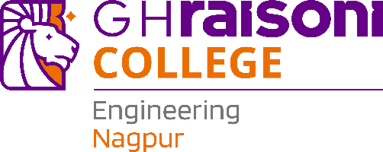

**Department of Electronic & Telecommunication**

**Engineering**

# **Subject:** Wireless Sensor Network (UECL412)

**TAE – 1:** Topic Review

**Topic:** Multiple Access Techniques

# **Name: -** Abhirat A. Bawane.

**Roll No:** 19

**Year/Semester:** 4th/ 7th

**Submitted To:** Dr. Bhushan Vidhale.

Signature:

**Introduction**

Multiple access techniques are crucial methods in telecommunications that enable multiple users to share the same communication resources—such as wireless spectrum, channels, or bandwidth—efficiently and reliably. These techniques allocate parts of the transmission medium in ways that minimize interference and maximize throughput, letting multiple users or devices communicate simultaneously over common channels. Channels can be divided and regulated by space, frequency, time, and code dimensions. In wireless networks, the natural transmission medium (air) is shared among all users. Without proper access control, signals could collide, leading to loss of communication or poor performance. Multiple access methods are therefore vital to support many users—especially as network capacities and user demands grow in modern cellular, Wi-Fi, and satellite systems.

**Types of Multiple Access Techniques**

1. FDMA (Frequency Division Multiple Access)

* Each user gets a **separate frequency band.**
* Used in **1G systems, satellite communication.**
* **Advantage:** Simple, less interference.
* **Disadvantage:** Inefficient if channels are idle.

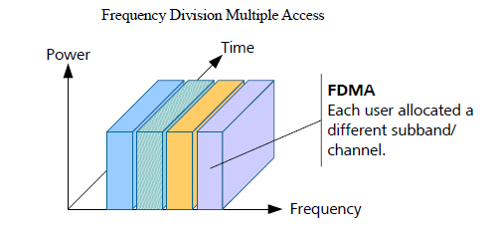

2. TDMA (Time Division Multiple Access)

* Each user gets a specific time slot on the same frequency.
* Used in 2G GSM.
* Advantage**:** Efficient use of bandwidth.
* Disadvantage**:** Requires synchronization.

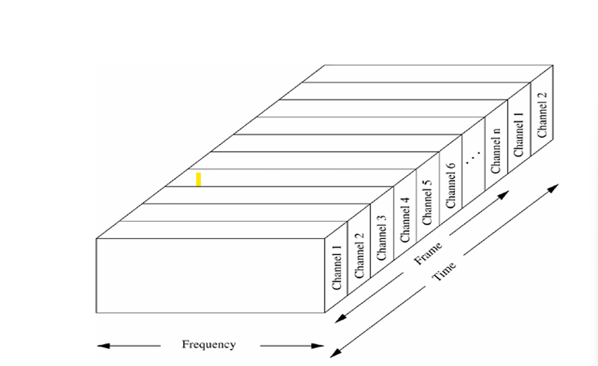

3. CDMA (Code Division Multiple Access)

* All users share the same frequency and time but use unique codes.
* Used in 3G networks.
* Advantage: High capacity, secure.
* Disadvantage: Complex and needs power control.

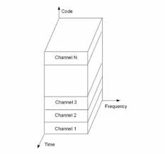

4. OFDMA (Orthogonal Frequency Division Multiple Access)

* Divides the channel into multiple subcarriers for different users.
* Used in 4G LTE and 5G.
* Advantage: High speed, efficient.
* Disadvantage: Sensitive to synchronization errors.

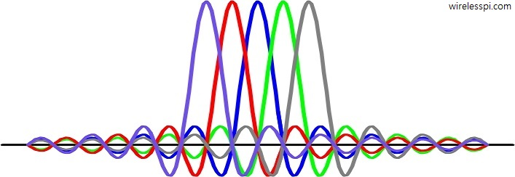

5. SDMA (Space Division Multiple Access)

* Users separated based on location/antenna beams.
* Used in satellites and 5G MIMO systems.
* Advantage**:** High capacity.
* Disadvantage**:** Requires advanced antennas.

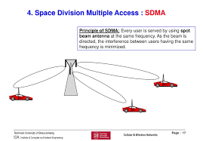

6. NOMA (Non-Orthogonal Multiple Access)

* Multiple users share **same frequency and time with different power levels.**
* Used in **5G and IoT.**
* **Advantage:** Better spectrum utilization.
* **Disadvantage:** Complex receiver design.

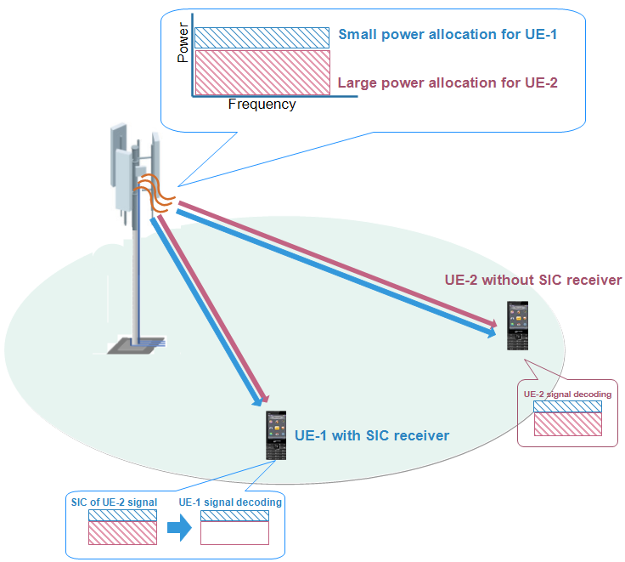

Conclusion

Multiple access techniques such as FDMA, TDMA, CDMA, OFDMA, and NOMA form the backbone of modern wireless communication systems by enabling multiple users to share limited communication resources efficiently and without interference. These methods allocate access to channels based on frequency (FDMA), time (TDMA), unique codes (CDMA), orthogonal frequency subcarriers (OFDMA), or power levels and codes (NOMA), each offering distinct advantages suited to different network requirements and technologies.

The choice of technique depends on factors like network design, user density, data rates, and latency demands. Advanced systems often use hybrid approaches combining multiple techniques to optimize performance. Multiple access methods continue to evolve, integrating intelligent algorithms and new access paradigms to meet the growing complexity and scale of wireless communication.